TECHNICAL DATASHEET

Product Details

Make : SUDEEP
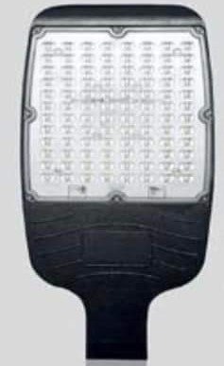
Model : SELMNW110
Series : LED Street Light
BIS CRS No. : R-71015989

Electrical Data

Input Voltage Range : 140 - 270 VAC
Power : 110 Watt
Power Factor : >0.95
Frequency : 50/60 Hz
Protections : THD < 10%
Driver : Constant Current Active
Power Factor Corrected
Lumens O/P : >12500 Lm

Light Data

LED Efficacy : >110 lm/Watt
Beam Angle : >80 ⁰
CCT : 6000 K +/- 100
Environmental

Working temperature : -10 to +50 Deg. Cel.
Working humidity : 10 to 90%
IP rating : IP66
Protection : IK07
Surge Protection : 5KV (Internal),

CRI : >70
LED Make : Osram
LED Type : SMD 2835
LED Life Time : 50,000 hours

Size

L x H x W : 330 x 315 x 65 mm
Warranty : 2 Years
Body Colours : Grey

Applications

Manufacturing Plants, Shop Floor, Industrial Areas, Godown, Shops, Warehouses, Storage Units




